For this exercise, we will use Dr. Khoo’s minimal insulin/glucose model (given in Canvas) with modifications by Dr. Roth and Dr. Lieber as discussed in class.
- First, run the model with initial conditions of a normal adult:
  - Simulation time = 10 hr.
  - Initial blood sugar = 0.81mg/ml
  - Initial insulin level = 0.057 IU/ml
  - Note that the Type 1 severity gain (after β) modulates insulin production, and the Type 2 severity gain (after ν) modulates insulin sensitivity by the insulin dependent glucose transporters. Set Type 1 severity gain (after β) = 1 & Type 2 severity gain (after ν) = 1
  - Q_{L} = 8400 mg/hr. → glucose produced by the fasting liver by glycogenolysis
  - Pulsed Glucose injection amplitude = 0
  - Note that these insulin and glucose levels are typical of fasting levels for a normal, non-diabetic, individual.
  - Show your plots (appropriately labeled, of course)
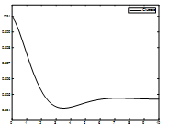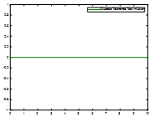
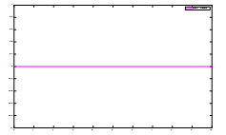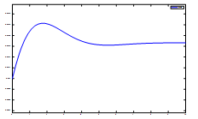
- With same settings for Q_{L}, β, and$ν$ change the setting on the pulse generator to simulate an oral glucose tolerance test. In this test 75 gm (7.5e4 mg) of glucose is swallowed. It is rapidly absorbed after ingestion (about ½ hr.). Reset the pulse generator for a:
  - period of 10 hours to match the runtime,
  - an amplitude of 7.5E4 (7.5E4 mg = 75 gm),
  - a pulse width of 5% (5% of 10 hours = 30 min)
  - Now run the simulation.
  - Show your graphs for glucose levels, insulin levels, and urine glucose levels.
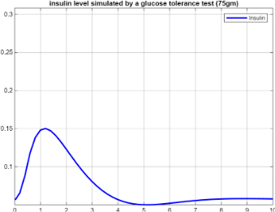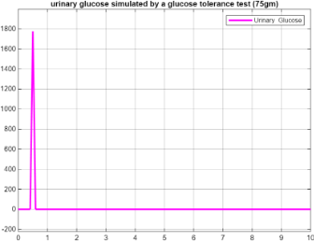
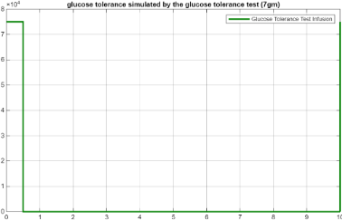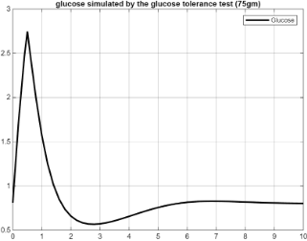
  - How long did it take for the blood glucose level to return to 2 mg/ml?... to 1.4 mg/ml? Here is a reworded version of your statement:
It took approximately 0.8 hours for the concentration to return to 2 mg/mL, and a level of 1.4 mg/mL was achieved in 1.105 hours.
- Now reset the parameters to simulate a type II diabetic patient:
  - Type 1 severity gain (after β or insulin production) = 0.6 & Type 2 severity gain (after eta or insulin resistance) = 0.4
  - Pulse generator amplitude = 0
  - Initial blood sugar = 0.8 mg/ml
  - Initial insulin levels = 0.057 IU/ml
  - Q_{L} remains at 8400 mg/hr.
  - Run the simulation and show your plots.
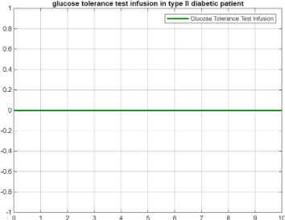
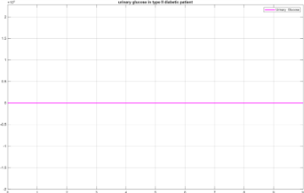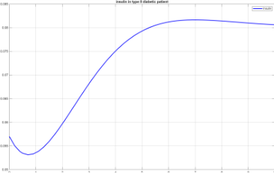
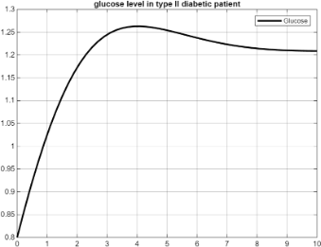
  - Make note of the final glucose and insulin levels. These are good approximations of the fasting levels for this type II diabetes.
The final measured concentrations of glucose and insulin serve as representative estimates of the fasting levels in this model of type II diabetes. Urinary glucose levels and the value for the tolerance test infusion remain at zero, as these do not surpass the maximum renal reabsorption threshold. The experiment concluded with a glucose concentration of 1.20873 and an insulin concentration of 0.0806181.
- For this diabetic, reset the pulse generator to simulate an oral glucose tolerance test exactly as before with a starting glucose level set at the fasting level you just foundmg/ml and the same for the starting insulin level.
  - Simulate the glucose tolerance test
  - Show your graphics
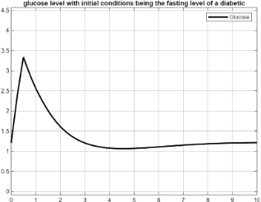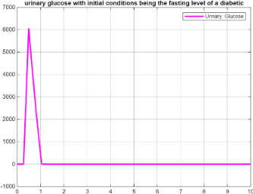
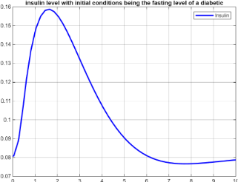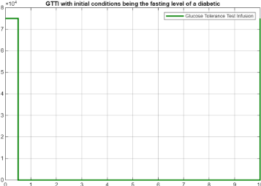
  - How long did it take for the blood sugar to return to 2 mg/ml?...to 1.4 mg/ml?
The time required for blood glucose concentration to return to 2 mg/mL was 1.5 hours. Subsequently, the concentration decreased further to 1.4 mg/mL over a period of approximately 2.4 hours. These measurements provide important kinetic insights into glucose regulation dynamics in the studied system.
- The glucose tolerance test is considered positive (diabetes present) if the post-ingestion serum glucose level is greater than or equal to 2 mg/ml (200 mg%) in 1 hour or greater than or equal to 1.4 mg/ml in 2 hours.
  - What were these values in the simulation of the normal person’s oral glucose tolerance test and in the simulation of the diabetic’s OGTT?
The administered oral glucose tolerance test was identical for both subjects, involving the ingestion of 75 grams of glucose. This protocol was applied to both a healthy individual and a fasting patient diagnosed with type 2 diabetes, allowing for comparative assessment of glucose metabolism under equivalent conditions.
  - Note that the fasting blood glucose level in our diabetic was 1.20mg/ml. The American Diabetic Associations criteria for the diagnosis diabetes is a fasting blood sugar of 1.26 mg/ml or more on two separate mornings (two successive mornings since on occasion, person without diabetes may have a fasting blood sugar of 1.26mg/ml or slightly more). Although we have set the gains to simulate a diabetic, the ADA criteria for diabetes were not met. Do the results of the oral glucose tolerance test indicate the presence of diabetes mellitus (see criteria above)?
The fasting blood glucose level measured in the diabetic subject was 1.20 mg/mL. According to the American Diabetes Association (ADA), a diagnosis of diabetes requires a fasting blood glucose level of 1.26 mg/mL or higher on two separate occasions, typically measured on consecutive mornings, as transient elevations can occur in non-diabetic individuals. Although the simulation parameters were set to replicate diabetic conditions, the fasting glucose level in this case did not meet the ADA diagnostic threshold for diabetes. Furthermore, analysis of the oral glucose tolerance test results does not support a diagnosis of diabetes mellitus; the 2-hour post-load glucose levels ranged between 1.4 mg/mL and 2.0 mg/mL, indicative of impaired glucose tolerance or prediabetes rather than overt diabetes.
  - Review the definition of sensitivity and specificity of a test.
  - From your results, which test would you think to be more sensitive for the diagnosis of diabetes, the fasting blood sugar, or the oral glucose tolerance test?
The fasting blood glucose test is less sensitive for diagnosing diabetes mellitus as it may fail to detect individuals whose blood glucose levels become elevated only after glucose intake. Consequently, this test cannot reliably identify cases of prediabetes or early-stage diabetes, although it possesses higher specificity due to fewer variables tested, resulting in a lower rate of false positives. Conversely, the oral glucose tolerance test (OGTT) demonstrates greater sensitivity in diagnosing diabetes because it can reveal glucose metabolism abnormalities not detected by fasting glucose measurements, particularly during prediabetes and the initial stages of the disease. Therefore, the OGTT is considered a more sensitive diagnostic tool than the fasting blood sugar test.
  - Which test will have more false negatives, the more sensitive test or the less sensitive one?
False negative results occur when a diagnostic test fails to identify an existing condition. The more sensitive test will produce fewer false negatives, as it is better equipped to detect true cases of the disease. Conversely, a less sensitive test, such as the fasting blood glucose measurement, tends to yield a higher number of false negatives by missing cases of diabetes that the more sensitive test could identify.

- Faced with a newly diagnosed diabetic, one can decide if the person is a type 1 diabetic or type 2 diabetic by sending blood insulin levels and/or testing for the presence of anti-pancreatic beta cell antibodies.
  - Explain how an insulin level or an anti-pancreatic beta cell antibody level from the lab can differentiate a type 1 from a type 2 diabetic.
Type 1 diabetes is characterized by autoimmune destruction of pancreatic beta cells, which are responsible for insulin production. Consequently, individuals with type 1 diabetes typically exhibit very low or undetectable circulating insulin levels and require exogenous insulin administration to maintain glucose homeostasis. In contrast, type 2 diabetes initially involves insulin resistance, where pancreatic beta cells may compensate by producing normal or elevated levels of insulin. Over time, however, beta cell function may decline, leading to reduced insulin secretion, though usually not to the profound deficiency seen in type 1 diabetes.
Laboratory differentiation between type 1 and type 2 diabetes can be achieved through measurement of insulin levels and detection of autoantibodies directed against pancreatic beta cells. Presence of autoantibodies, such as insulin autoantibodies (IAA) and zinc transporter 8 autoantibodies, is indicative of the autoimmune nature of type 1 diabetes. These autoantibodies are absent in type 2 diabetes, allowing clear discrimination between the two forms of the disease.
  - Why is it important to make this differentiation?
Differentiating between type 1 and type 2 diabetes is clinically important because the two conditions require markedly different management strategies. In type 2 diabetes, inappropriate administration of exogenous insulin without proper indication can lead to adverse outcomes, as patients often have elevated endogenous insulin levels and may be primarily insulin resistant. Conversely, type 1 diabetes patients lack sufficient insulin production due to autoimmune destruction of pancreatic beta cells and thus depend on insulin therapy for survival. Furthermore, type 1 diabetes carries a significant risk of diabetic ketoacidosis, a potentially life-threatening complication where the absence of insulin leads to increased fat breakdown for energy. On the other hand, type 2 diabetes is associated with a heightened risk of chronic complications, including cardiovascular disease, nephropathy, and neuropathy, necessitating comprehensive management of metabolic and cardiovascular risk factors.
- The drug of choice, as a first drug, to treat type II diabetes mellitus is metformin. This drug has few and rare adverse side effects, never causes hypoglycemia, and is effective. It works by reducing the hepatic production of glucose by 50% when the drug is at 100% blood concentration for a one-gram dose (= 1e6 mcg). The rate by which the hepatic production of glucose increases, and the plasma level decreases is proportional (i.e. the glucose excreted by the liver increases exponentially as the concentration of the drug decreases exponentially).
  - Design a one compartment model for oral metformin administration showing metformin plasma levels. N.B. the model presented in class is for IV, not oral, administration of the drug.
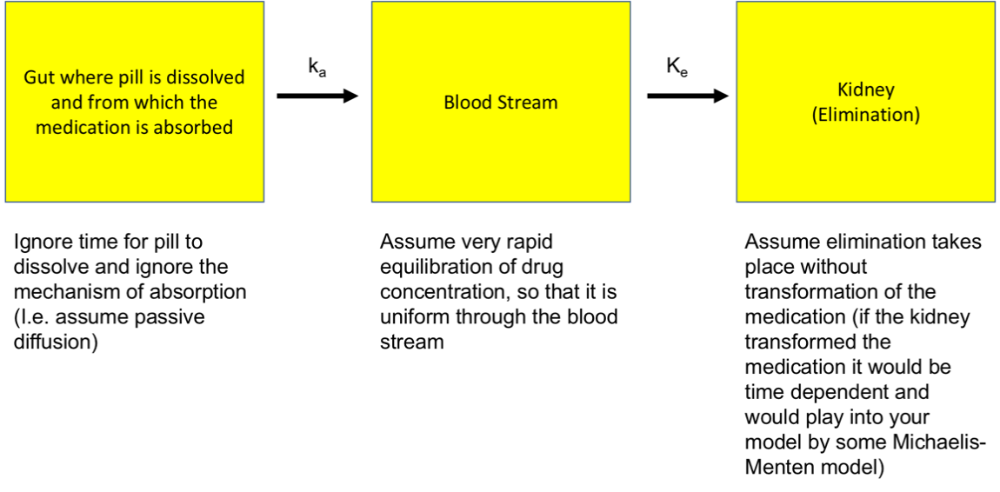
  - For this model use the following parameters:
volume of distribution (V_{d}) = 15 liters (15,000 ml),
absorption constant, k_{a} = 0.275
excretion constant, k_{e} = 0.25
dose = 1 gm =1 x 10⁶ mcg
bioavailability (F) = 95%
  - In addition to the above, on your submitted plot indicate:
    - the length of time from administration of metformin to peak plasma concentration.
The length of time from administration of metformin to peak plasma concentration is 3.96 hours, with the corresponding peak concentration being 24.4 mg/L.
    - time to half-life of the drug, i.e., total time from administration, through the peak, until the blood concentration returns to ½ peak concentration
The half-life of the drug is defined as the total time elapsed from administration, through the attainment of peak plasma concentration, until the plasma concentration decreases to half of its peak value. For this model, the half-life corresponds to 10.23 hours post-administration, at which point the plasma concentration is 12.2 mg/L.
    - duration of action.
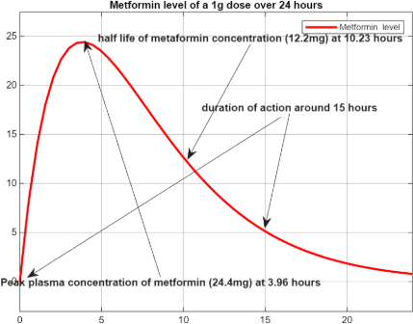
The duration of action of the drug spans from the time of administration up to 10.23 hours, during which the plasma concentration decreases from its peak level to half of that maximum.

  - As stated, metformin will diminish the hepatic production of glucose proportionately to its concentration. If one gram of metformin is ingested, the result will be that the hepatic production of glucose will be halved at peak drug concentration. Using the model developed above, make a model that links the time dependent concentration of metformin to the production of glucose by the liver. Submit your model and the plot of your outputs.
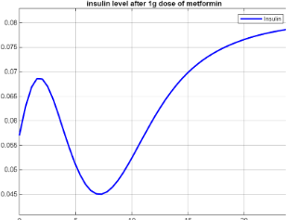
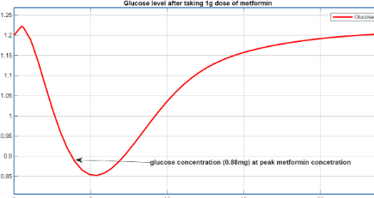
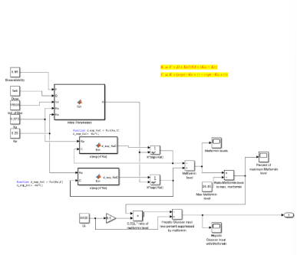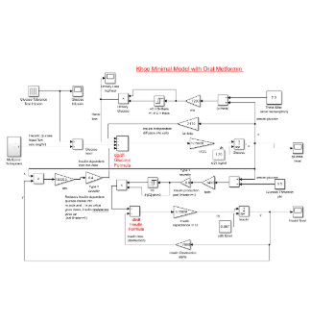
Upon examination of the insulin levels at 3.96 hours, corresponding to the time of peak plasma concentration of metformin, the insulin concentration was observed to be approximately half of that measured in the diabetic simulation described in question 4. Additionally, the glucose concentration had not yet reached its minimum value at this time point, which may be attributable to the limitation of using a one-compartment pharmacokinetic model as well as the absence of Michaelis-Menten kinetics in the model.
- The only drugs to treat type I diabetes mellitus is one of the multiple available forms of insulin (naturally occurring insulin from the pancreas of other animals - bovine or porcine, recombinant insulin, recombinant insulin modified to delay resorption or to increase the time of action by prolonging the attachment to the insulin receptors , etc.). Short acting recombinant human insulin (Humulin®) is injected subcutaneously. Peak blood concentrations are reached at about 45-75 minutes or 0.75 to 1.25 hours (your model ought to reach peak concentrations somewhere in that timeframe). Its duration of action is about 5 hours (again the serum concentration should start at zero and should be trending towards zero at about 5 hours). Half-life after reaching peak concentration is about ±3.
  - According to the literature from Eli Lilly, the manufacturer of Humulin:
  - the volume of distribution is about 0.3 L/Kg. For a 100 Kg individual (weight chosen for convenience) that comes to a V_{d} of 30 L.
  - Design a one compartment model for the insulin subcutaneous injection of 30 international units of insulin.
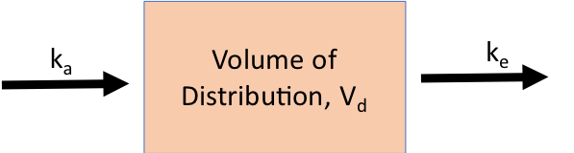
Eli Lilly gives the following parameters:
Constant of absorption = 1.55
Constant of excretion = 0.43
Bioavailability =0.65 (as per Lilly)
you will be giving a dose:
Dose = 30 IU = 3e4 mU (0.3 IU/Kg in a 100 Kg individual)
Volume of distribution 30 L
  - Now couple this model of insulin blood levels to the minimal glucose/insulin model and demonstrate what this injection does to the fasting blood sugar of a fasting type 1 diabetic. Remember a type 1 diabetic does not produce insulin. The model needs to be revised appropriately (see below). Make sure the pulse generator is reset to zero to simulate a fasting patient.
    - First, determine the fasting blood sugar in a type I diabetic. To do this set the parameters in the gains appropriately:
      - $β \left(controls insulin production\right)gain=0 υ \left(insulin dependence\right)gain=1$)
      - the initial insulin level in the insulin integrator is set to zero.
    - Run the model. Record the final glucose level (Steady state value). This will be the initial glucose level in your new model.
  - To couple the injection model to the minimal glucose/insulin model you need to realize a few things:
    - There is no longer a feedback between the glucose level and the insulin secretion. There is no production of insulin by the pancreas.
    - The insulin injection model you made has already considered with the k_{e} factor the destruction and elimination of insulin.
    - Your model for the injection of insulin has totally mapped the levels of insulin, i.e. the volume of distribution in the injection of insulin model replaces the capacitance of insulin in the minimal glucose/insulin model
    - Large parts of the minimal glucose/insulin model can be eliminated and replaced with the insulin injection model. This is what happens in type I diabetics. The feedback mechanisms to produce insulin and the control between insulin levels and glucose levels no longer exists. That is how type I diabetics get into serious medical emergencies. They risk severe, potentially fatal, hypoglycemia or hyperglycemic episodes with severe acidosis which are also potentially fatal.
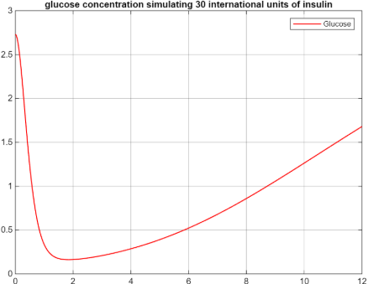
  - Now use the model with the insulin injection coupled into the minimal glucose/insulin model. Run your simulation for the total duration of the drug – about 12 hours.
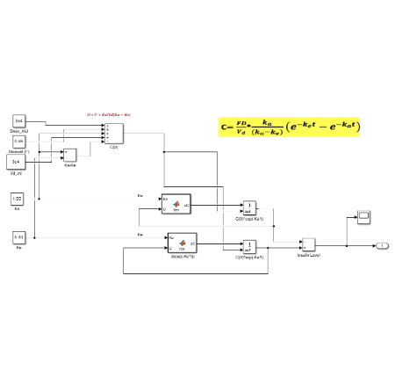
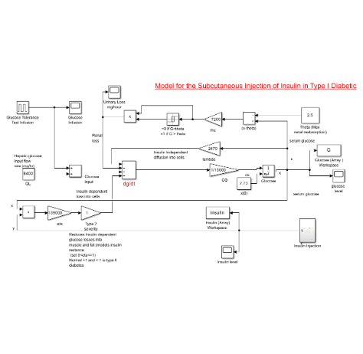
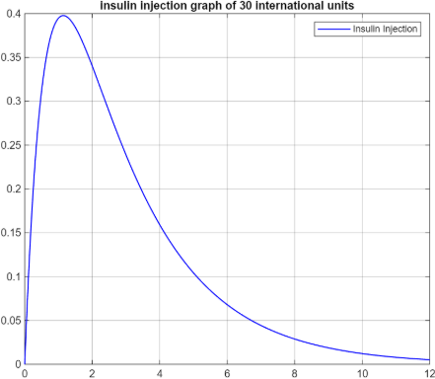
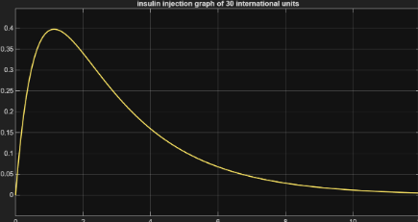
  - Study the glucose response in the simulation (show your plots and your model in your submission).
The half-life of insulin is approximately 3.4 hours, reflecting the time required for the plasma concentration of insulin to decrease by 50% after reaching its peak concentration.
  - What is the glucose nadir?
The glucose nadir, representing the lowest plasma glucose concentration observed during the study, was measured at 0.162 mg/dL
  - Look up normal glucose levels and research what are considered low and dangerous glucose levels. What are they?
Normal fasting blood glucose levels are generally considered to be between 77 and 99 mg/dL (4.3 to 5.5 mmol/L). After a meal, blood glucose levels should typically remain below 140 mg/dL (7.8 mmol/L).
Blood glucose levels below 70 mg/dL (3.9 mmol/L) are considered low (hypoglycemia), and levels at or below 50 mg/dL are often regarded as dangerously low, potentially leading to severe symptoms such as loss of consciousness or seizures. Maintaining blood glucose within the normal range is crucial for proper physiological functioning and to avoid these complications.
  - Research what occurs with low or dangerous glucose levels. Include these findings in your submission.
During episodes of dangerously low blood glucose, or hypoglycemia, the body initiates a comprehensive endocrine response to restore glucose homeostasis. The pancreas secretes glucagon, which stimulates the liver to convert glycogen reserves into glucose and release it into the bloodstream. Simultaneously, the adrenal glands release epinephrine, increasing heart rate and blood pressure to enhance glucose delivery throughout the body. The pituitary gland secretes growth hormone, which reduces glucose uptake by muscles and promotes hepatic glucose output. Additionally, cortisol is released to raise blood glucose concentrations via gluconeogenesis. These coordinated hormonal mechanisms act collectively to counteract hypoglycemia and safeguard cerebral glucose supply.
  - If significant hypoglycemia occurred in your model, how would the body react to counter the hypoglycemia? What other endocrine responses would you expect to occur (not accounted for in your model) before the blood sugar gets to these levels?
In the event of significant hypoglycemia within the model, the body would initiate an endocrine response wherein the pancreas secretes glucagon to stimulate hepatic glycogenolysis, converting stored glycogen into glucose which is then released into the bloodstream. The adrenal glands would release epinephrine to elevate heart rate and blood pressure, thereby enhancing glucose distribution. Additionally, the pituitary gland would secrete growth hormone to decrease glucose uptake by muscle tissue and promote further hepatic glucose output. Cortisol secretion would also increase, augmenting blood glucose levels through gluconeogenesis. These hormonal responses collectively act to restore blood glucose levels prior to the onset of severe hypoglycemia, though some of these mechanisms were not incorporated in the current model."

  - Remember that the simulation was an insulin injection on a fasting patient. When would you recommend that a diabetic patient inject Humulin: fasting or just before meals?
In the context of an insulin injection administered to a fasting patient, it is advisable for a diabetic to inject Humulin prior to meals rather than during fasting. Administering insulin during fasting can precipitate hypoglycemia due to the absence of exogenous glucose intake to counterbalance insulin-induced glucose uptake. Conversely, injecting insulin before meals allows endogenous or ingested glucose to mitigate insulin-driven glucose reduction, thereby minimizing the risk of hypoglycemic episodes and attenuating postprandial blood glucose excursions.

